- January's small fall in UK GDP is no cause for concern given it came on the back of December's outsized increase. We continue to expect quarter-on-quarter growth of around 0.3% in Q1, though a history of volatility in the early part of the year – likely reflecting residual seasonality in the data – means there's still some uncertainty around this call.
- This week's output data is unlikely to have much influence on the Monetary Policy Committee's thinking. We expect next week's MPC meeting to result in Bank Rate remaining at 4.5%, with the only real uncertainty being whether two or three members vote for a cut.
The week's only major data release was the GDP estimate for January. Output was reported to have fallen 0.1% month-on-month in January, bang in line with our expectations. Given January's drop came on the back of a hefty 0.4% m/m increase in December, it's no cause for concern. Most of those sectors that had a very strong December – such as art and recreation, extraction, accommodation and food, and manufacturing – suffered chunky falls in January to take the level of output back to levels closer to where they had been for much of H2 2024 (Chart 1).
Given the strong launchpad offered by December's outturn, we're on track to see GDP grow by around 0.3% quarter-on-quarter in Q1. This would be a step up on the relatively flat performance of H2 2024. But as we've argued previously, we suspect the strength of H1 2024 and subsequent slowdown in H2 was exaggerated by problems with residual seasonality in the data. Moreover, the past couple of years have seen strong month-on-month growth in February of each year, so if that pattern continues then we could see an even stronger outturn for Q1.
We will incorporate the January GDP data into our forecast when we publish our UK Country Economic Forecast next week. But given the new data was in line with expectations and there were no historical revisions, we don't expect to change our forecast that UK GDP will grow by 1% this year. This projection is consistent with the slightly below trend pace we forecast for Q1 continuing throughout the rest of 2025.
Chart 1: January's modest fall in GDP only gave back a little of December's strong gain
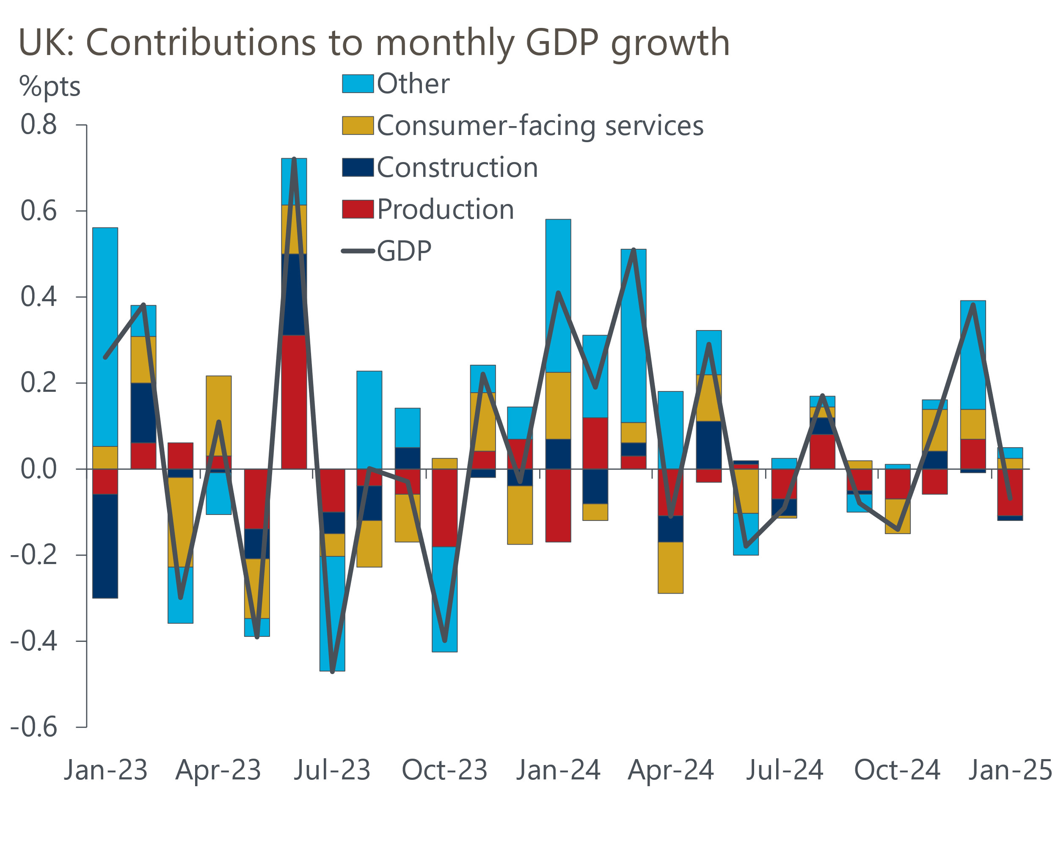
Source: Haver Analytics

Regrettably, data issues came to the fore again, with the accompanying monthly trade release being postponed by a couple of weeks following the discovery of an error in the data processing system for the services data. The Office for National Statistics reported that the error means that the level of services exports and imports has been underestimated between 2023-2024, with the size of the error for the level of trade ranging from 2% (services imports in 2023) to 6% (services exports in 2024). Even in the context of very volatile series, these are not trivial differences. And coming on the back of the long-running saga of the Labour Force Survey, this development further undermines the credibility of the UK's official statistics.
The ONS also published a couple of reviews this week. The first was the National Statistician’s Independent Review of Public Services Productivity measurement, which made a large number of recommendations for improvements in an area that has long been a source of concern. The improvements will be gradually introduced into the national accounts over the next few years, raising the likelihood of sizeable revisions to the historical output data for these sectors and, potentially GDP.
The second review confirmed the ONS's determination to continue publishing market sensitive UK data at 7am. The ONS's main argument in favour is that a 7am release time generates more media coverage. Other supporting arguments included the notion that the ONS's notoriously poor website would be put under less pressure at 7am than 9.30am, and the idea that a later release time would increase the chances of "false rumours of leaks". In our view, these arguments are incredibly weak and very easily debunked. But given the ONS is so determined to stick to 7am, it seems unlikely this policy will change any time soon.
The implications of soft demand, and its interaction with the UK's long-running supply weakness, have been key themes of recent Bank of England Monetary Policy Committee meetings, with a broad range of views on the committee about whether demand or supply is the dominant influence on the inflation outlook. The recent Treasury Select Committee hearing was a good example, with Governor Andrew Bailey and external MPC member Alan Taylor expressing concerns about the fragility of demand but BoE Chief Economist Huw Pill and external member Megan Greene more worried about supply weakness.
This week's data is unlikely to have made much difference to the debate and we expect next week's MPC meeting to be fairly low key, with a 7-2 or 6-3 vote to keep Bank Rate at 4.5%. The only real question mark is over whether Taylor votes to cut. He voted for back-to-back cuts in December, and when appearing before the Treasury Select Committee, he argued that the fall in inflation last year occurring alongside a slowdown in activity was "first-order evidence that the shock to demand was dominating". However, he also cited concerns about the likely scale of regulated price rises in April and the recent strength of the official pay series. He characterised his February vote to cut by 25bps as steering a middle course through those factors; this time around the middle course is likely to be a vote to hold.
The cut-hold tempo for policy loosening has become well established and is likely to remain the default option until at least the summer. The next serious threat to the gradual pace of rate cuts is likely to come from evidence of the impact of April's increases in regulated prices, employers' national insurance contributions, and the national living wage. But the MPC will not have data on the labour market part of this equation until at least the August meeting. The only way that the MPC could be forced to act sooner would be if the output data takes a sudden turn for the worse. But this week's data suggests that remains a tail risk.

The week ahead
We expect the Monetary Policy Committee to hold Bank Rate at 4.5% at next week's meeting. The main uncertainty is whether two or three members vote for a rate cut, with Alan Taylor the member who is hard to place. Taylor voted for back-to-back cuts in December and his recent testimony to the Treasury Select Committee made clear that he thought weak demand was the dominant factor in the inflation outlook. However, he also cited concerns about the likely scale of regulated price rises in April and the recent strength of the official pay series. We lean towards Taylor voting to hold but with low conviction.
Next week's only major data release is the monthly labour market statistics. All measures of pay growth accelerated in late-2024, reflecting a combination of favourable base effects and solid momentum. But the base effects will now start to fade, and we expect pay growth to stabilise. For the three months to January, we forecast total pay growth of 5.9% and regular pay growth of 6%.
There's been more stability in recent single-month Labour Force Survey results for unemployment, so we expect the three-month average to remain at 4.4% for the three months to January.
Table 1: Week ahead calendar
Date | Events | Period | Measure | Unit | Previous | Forecast
Mar 20 | LFS unemployment | Nov-Jan | Rate | % | 4.4 | 4.4
Mar 20 | Average earnings (total pay) | Jan | 3m, y/y | % | 6.0 | 5.9
Mar 20 | Average earnings (regular pay) | Jan | 3m, y/y | % | 5.9 | 6.0
Mar 20 | BoE Bank Rate decision | Mar | Bank Rate | % | 4.50 | 4.50
Mar 21 | GfK consumer confidence | Feb | Headline | % bal | -20 | -19
Mar 21 | Public finances | Feb | PSNB ex | £bn | -15.4 | 7.0
Source: Oxford Economics

Key forecasts
Table 2: UK forecast overview
(Annual percentage changes unless specified)
 | 2022 | 2023 | 2024 | 2025 | 2026 | 2027
GDP | 4.8 | 0.4 | 0.9 | 1.0 | 1.5 | 1.7
Private consumption | 7.3 | 0.4 | 0.7 | 1.2 | 1.4 | 1.4
Fixed investment | 5.1 | 0.3 | 1.3 | 0.1 | 3.1 | 2.4
Government consumption | 0.6 | 1.0 | 2.0 | 2.4 | 1.6 | 1.6
Exports of goods and services | 12.6 | -3.2 | -2.2 | -1.6 | 0.9 | 1.3
Imports of goods and services | 13.0 | -4.5 | 1.6 | 0.0 | 1.5 | 1.2
Industrial Production | -6.4 | -0.9 | -1.7 | -0.6 | 0.8 | 1.0
Consumer prices | 9.1 | 7.3 | 2.5 | 3.2 | 2.6 | 2.2
Unemployment rate (%) | 3.8 | 4.1 | 4.3 | 4.5 | 4.5 | 4.3
Current a/c balance (% of GDP) | -2.2 | -2.2 | -2.8 | -2.9 | -2.9 | -2.7
Government balance (% of GDP) | 4.1 | 5.2 | 5.0 | 3.7 | 3.1 | 2.4
Central bank policy rate (%, EOP) | 3.50 | 5.25 | 4.75 | 3.75 | 3.00 | 2.50
10yr govt. bond yield (%, EOP) | 3.67 | 3.54 | 4.57 | 4.54 | 3.93 | 3.44
Exchange rate (US$ per £, EOP) | 1.20 | 1.27 | 1.25 | 1.25 | 1.25 | 1.26
Exchange rate (euro per £, EOP) | 1.13 | 1.15 | 1.21 | 1.21 | 1.21 | 1.21
Source: Oxford Economics
Table 3: Quarterly forecasts for the UK
 | 2024 |  |  |  | 2025
 | Q1 | Q2 | Q3 | Q4 | Q1 | Q2 | Q3 | Q4
GDP (% year) | 0.5 | 0.9 | 1.0 | 1.4 | 0.8 | 0.7 | 1.0 | 1.3
CPI inflation (% year) | 3.5 | 2.1 | 2.1 | 2.5 | 2.8 | 3.2 | 3.5 | 3.2
Bank Rate (%, EOP) | 5.25 | 5.25 | 5.00 | 4.75 | 4.50 | 4.25 | 4.00 | 3.75
10yr gilt yield (%, EOP) | 3.95 | 4.17 | 4.00 | 4.57 | 4.70 | 4.67 | 4.63 | 4.54
US$ per £ (EOP) | 1.26 | 1.26 | 1.34 | 1.25 | 1.28 | 1.25 | 1.25 | 1.25
Euro per £ (EOP) | 1.17 | 1.18 | 1.20 | 1.21 | 1.20 | 1.21 | 1.21 | 1.21
Source: Oxford Economics

Latest Country Economic Forecast:
February 20, 2025

Recent publications

Data Insights
GDP fell back in January but the prospects for Q1 remain decent
Q1 growth likely stronger than PMI suggests
Manufacturing PMI falls further into contractionary territory
Mortgage demand softened slightly at the start of 2025
PMI too pessimistic on Q1 growth performance

Research Briefings
MPC preview – More of the same
Four reasons why inflation will be well above target in 2025
Defence spending could still pose a fiscal challenge
What the rise in NICs means for the labour market
Two fiscal wild cards in the Spring Forecast

Contacts

Oxford Economics' UK team
- Andrew Goodwin - Chief UK Economist - agoodwin@oxfordeconomics.com
- Edward Allenby - UK Economist - eallenby@oxfordeconomics.com

